Point on a Plane

Definition
# Source: AI Source: Provided by: [Data Path: Persons Table -> ID Column: 1, Name_En Column: Motasem Essam] -> From: [ChatGPT] on [7/25/2026]
A point on a plane in solid geometry is a point whose position lies on a particular flat, two-dimensional plane in three-dimensional space.
A point in 3D space is represented by coordinates $\left(x,y,z\right)$. A point lies on a plane when its coordinates satisfy the equation of that plane.
For a plane with equation
$$ax+by+cz+d=0$$
a point $P\left(x,y,z\right)$ lies on the plane if
$$ax+by+cz+d=0$$
where $a,b,c,d$ are constants and $a,b,c$ are not all zero.

Simple Definition
# Source: AI Source: Provided by: [Data Path: Persons Table -> ID Column: 1, Name_En Column: Motasem Essam] -> From: [ChatGPT] on [7/25/2026]
A point on a plane is a point located exactly on a flat surface, such as a point on the floor of a room or on one face of a cube.
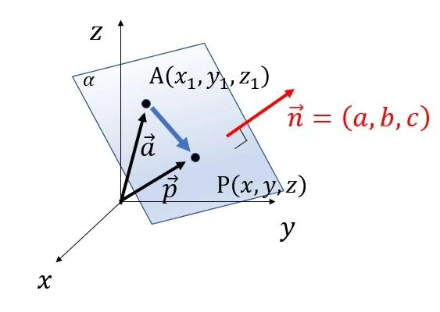
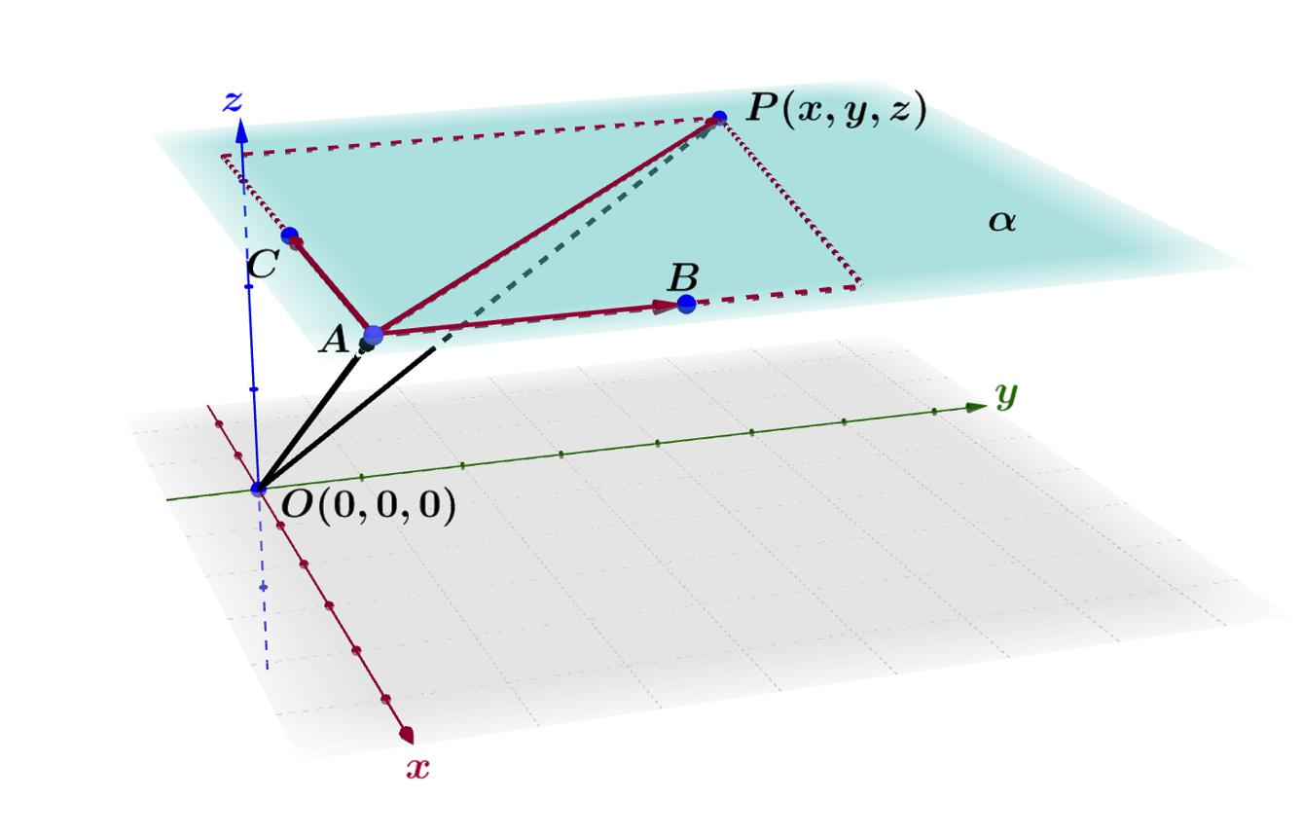
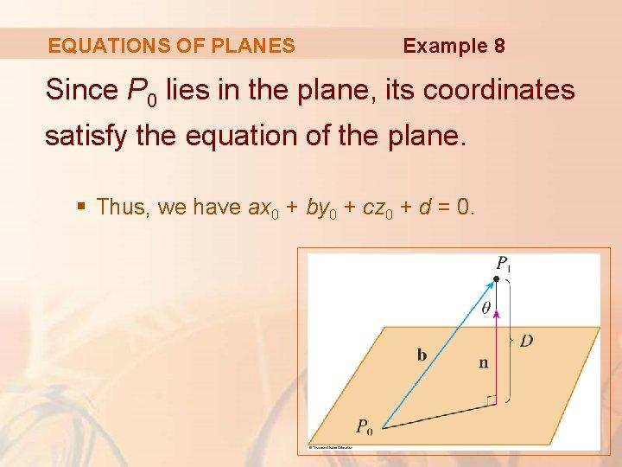

Key Characteristics
# Source: AI Source: Provided by: [Data Path: Persons Table -> ID Column: 1, Name_En Column: Motasem Essam] -> From: [ChatGPT] on [7/25/2026]
- Zero-dimensional: A point has no length, width, or height.
- Three-dimensional coordinates: Its position can be expressed as $\left(x,y,z\right)$.
- Plane membership: Its coordinates satisfy the plane's equation.
- No required position within the plane: It can lie anywhere on the infinite plane.
- Not necessarily on a solid: A plane extends infinitely, whereas a face of a solid is generally a bounded region.
- Can belong to multiple planes: A point on the line where two planes intersect lies on both planes.

Types of Points on Planes in Solid Geometry

1. Point on a Coordinate Plane
# Source: AI Source: Provided by: [Data Path: Persons Table -> ID Column: 1, Name_En Column: Motasem Essam] -> From: [ChatGPT] on [7/25/2026]
A point lies on one of the three principal coordinate planes when the corresponding coordinate equals zero.
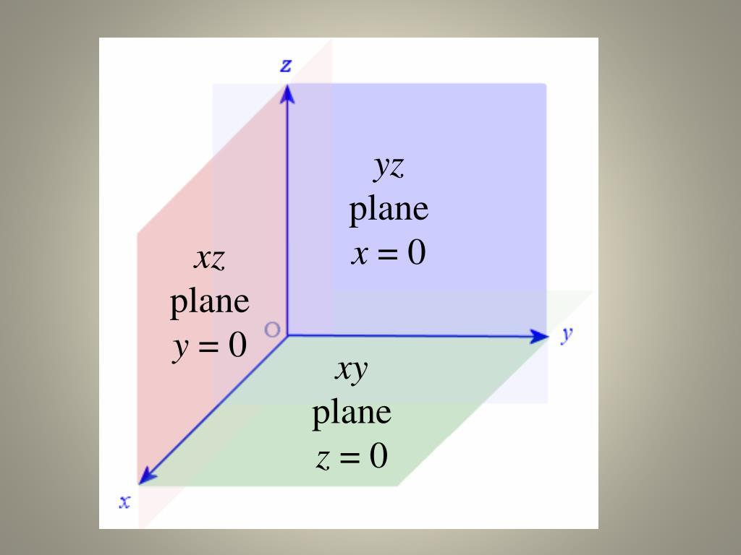
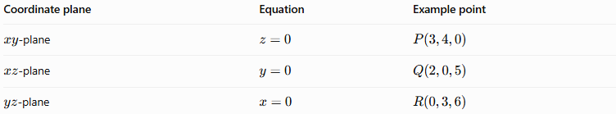
Coordinate plane | Equation | Example point
$xy$-plane | $$z=0$$ | $$P\left(3,4,0\right)$$
$xz$-plane | $$y=0$$ | $$Q\left(2,0,5\right)$$
$yz$-plane | $$x=0$$ | $$R\left(0,3,6\right)$$
Example: The point $P\left(3,4,0\right)$ lies on the $xy$-plane because its $z$-coordinate is zero.

2. Point on a General Plane
# Source: AI Source: Provided by: [Data Path: Persons Table -> ID Column: 1, Name_En Column: Motasem Essam] -> From: [ChatGPT] on [7/25/2026]
A point can lie on any plane, not just a coordinate plane.
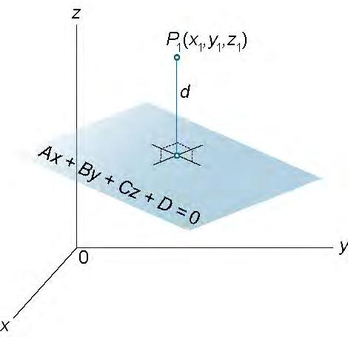
Consider the plane
$$2x+y-z-4=0$$
Determine whether $P\left(1,2,0\right)$ lies on it:
$$2\left(1\right)+2-0-4=0$$
Since the equation is satisfied, $P\left(1,2,0\right)$ lies on the plane.

3. Point on a Plane Containing a Solid's Face
# Source: AI Source: Provided by: [Data Path: Persons Table -> ID Column: 1, Name_En Column: Motasem Essam] -> From: [ChatGPT] on [7/25/2026]
A point may lie on one of the flat faces of a three-dimensional solid, such as a cube, cuboid, or prism.
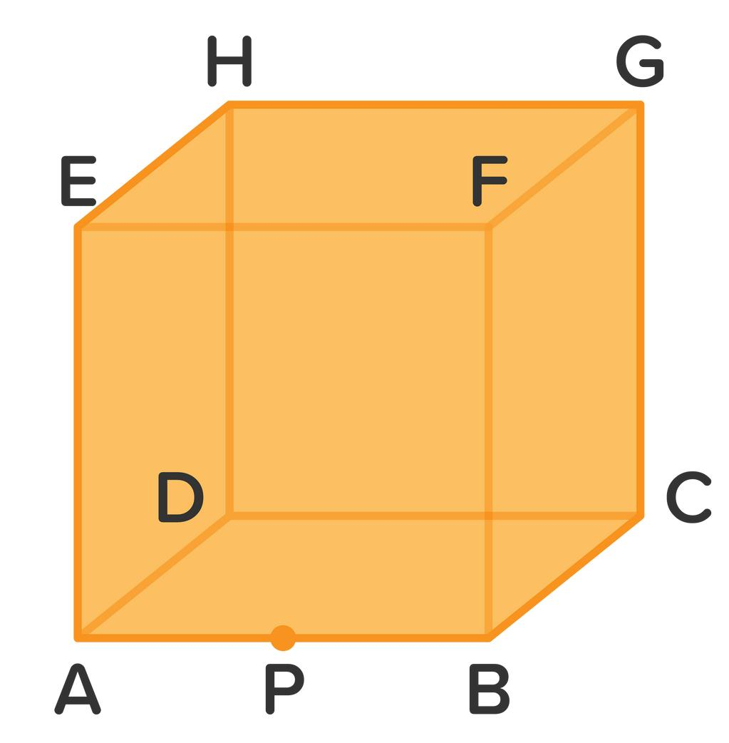
For a cube positioned with its bottom face on $z=0$ and its top face on $z=4$, a point $P\left(1,2,4\right)$ lies on the plane of the top face.
To lie on the face itself, rather than merely on its infinite supporting plane, the point must also fall within the face's boundaries.

4. Point at the Intersection of Planes
# Source: AI Source: Provided by: [Data Path: Persons Table -> ID Column: 1, Name_En Column: Motasem Essam] -> From: [ChatGPT] on [7/25/2026]
Two distinct, non-parallel planes in three-dimensional space generally intersect along a straight line. Every point on that line lies on both planes.
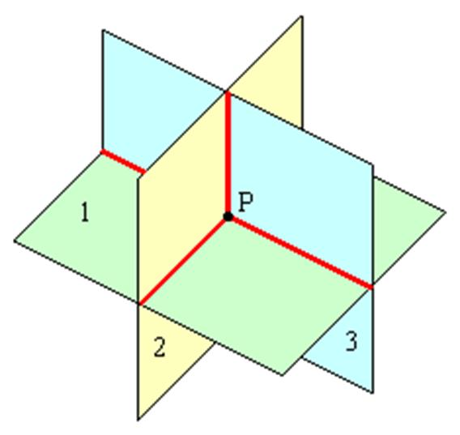
For example, consider
$$x+y=3$$
and
$$z=2$$
The point $P\left(1,2,2\right)$ satisfies both equations:
$$1+2=3, z=2$$
Therefore, $P$ lies on both planes and on their intersection line.

5. Point on a Plane's Boundary Region
# Source: AI Source: Provided by: [Data Path: Persons Table -> ID Column: 1, Name_En Column: Motasem Essam] -> From: [ChatGPT] on [7/25/2026]
A plane is infinite and has no boundary of its own. However, a bounded region within a plane, such as a square face or a triangular region, has a boundary.
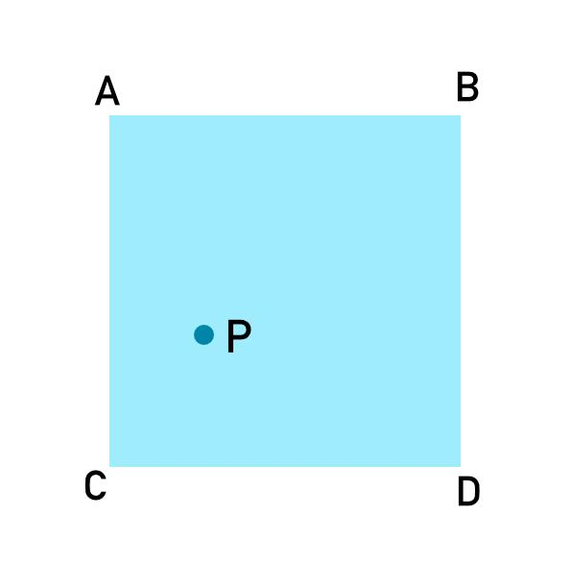
For a square face, a point can be:
- Inside the face: Within the square, not on its edges.
- On the boundary: On one of its edges or vertices.
- Outside the face: Outside the square, even if it remains on the same infinite plane.
These distinctions apply to the bounded region, not to the plane itself.

Mathematical Representation
# Source: AI Source: Provided by: [Data Path: Persons Table -> ID Column: 1, Name_En Column: Motasem Essam] -> From: [ChatGPT] on [7/25/2026]
General plane equation
$$ax+by+cz+d=0$$
A point $P\left(x_{0},y_{0},z_{0}\right)$ lies on the plane exactly when
$$ax_{0}+by_{0}+cz_{0}+d=0$$
Coordinate-plane equations
$$\begin{aligned}xy\text{-plane}:& z=0 \\ xz\text{-plane}:& y=0 \\ yz\text{-plane}:& x=0\end{aligned}$$
Distance from a point to a plane
For a point $P\left(x_{0},y_{0},z_{0}\right)$ and a plane $ax+by+cz+d=0$, the perpendicular distance is
$$D=\frac{\left|ax_{0}+by_{0}+cz_{0}+d\right|}{\sqrt{a^{2}+b^{2}+c^{2}}}$$
- If $D=0$, the point lies on the plane.
- If $D>0$, the point does not lie on the plane.

Worked Examples
# Source: AI Source: Provided by: [Data Path: Persons Table -> ID Column: 1, Name_En Column: Motasem Essam] -> From: [ChatGPT] on [7/25/2026]
Example 1: Point on the $xz$-plane
Is $A\left(5,0,2\right)$ on the $xz$-plane?
The equation is $y=0$. Since the $y$-coordinate of $A$ is zero, yes.
Example 2: Point on a general plane
Does $B\left(2,1,3\right)$ lie on $x+2y-z+1=0$?
$$2+2\left(1\right)-3+1=2$$
The result is not zero, so no, $B$ does not lie on the plane.
Example 3: Point on two planes
Does $C\left(1,2,3\right)$ lie on both $x+y=3$ and $z=3$?
Both equations are satisfied. Therefore, yes, $C$ lies on both planes.

Comparison with Related Concepts
# Source: AI Source: Provided by: [Data Path: Persons Table -> ID Column: 1, Name_En Column: Motasem Essam] -> From: [ChatGPT] on [7/25/2026]
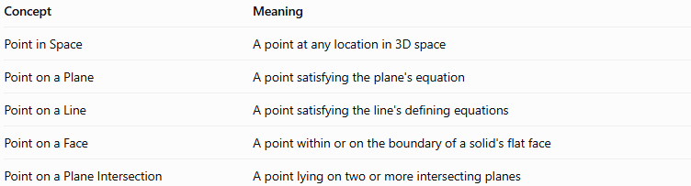
Concept | Meaning
Point in Space | A point at any location in 3D space
Point on a Plane | A point satisfying the plane's equation
Point on a Line | A point satisfying the line's defining equations
Point on a Face | A point within or on the boundary of a solid's flat face
Point on a Plane Intersection | A point lying on two or more intersecting planes

Applications
# Source: AI Source: Provided by: [Data Path: Persons Table -> ID Column: 1, Name_En Column: Motasem Essam] -> From: [ChatGPT] on [7/25/2026]
- Coordinate geometry: Testing whether a point satisfies a plane equation.
- 3D modeling: Locating vertices and surface points on a model.
- Computer graphics: Determining whether points lie on a surface.
- Architecture and engineering: Checking points on walls, floors, and other planar surfaces.
- Solid geometry: Studying the relationship between points, faces, and intersecting planes.

Key Points
# Source: AI Source: Provided by: [Data Path: Persons Table -> ID Column: 1, Name_En Column: Motasem Essam] -> From: [ChatGPT] on [7/25/2026]
- A point on a plane satisfies that plane's equation.
- The coordinate planes are characterized by one coordinate being zero.
- A point can lie on more than one plane.
- A plane is infinite, but a face is bounded.
- A point on a plane is not necessarily inside a particular face or solid.

Conclusion
# Source: AI Source: Provided by: [Data Path: Persons Table -> ID Column: 1, Name_En Column: Motasem Essam] -> From: [ChatGPT] on [7/25/2026]
A point on a plane is a fundamental positional concept in solid geometry. Its defining condition is that its coordinates satisfy the equation of the plane. Understanding this concept helps connect points with lines, planes, solid faces, and intersections in three-dimensional space.

